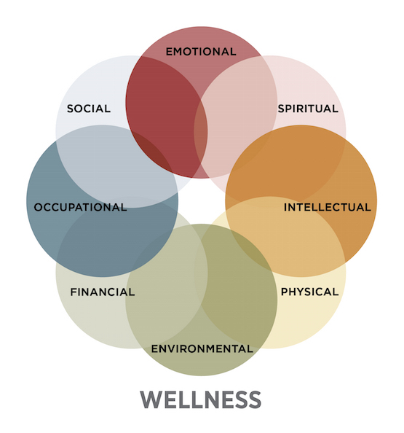
Ohio-At-Home Client Service Goals: 2019
Client: [client] - Natural Support: [guardian/support] - OAH Staff: [staff/role]

Summary:
The Goals listed below are goals for [client] entering [year]. [client/support] provided information regarding [client’s] service goals with Ohio-At-Home, and [staff] documented the information. Additionally, the goals were then translated into the eight categories of wellness.

Wellness can be defined as being in good physical and mental health. By approaching goals through a wellness perspective, it is easier for the client and family to better visualize how their self-determined goals will work toward their overall health.

The ‘8 Categories of Wellness’ was developed by SAMSHA, the Substance Abuse and Mental Health Administration, a branch of the U.S Department of Housing and Human Services.

Services Received from Ohio-At-Home: [Home Professional Care, Remote Support, Assistive Technology, Limited Program Specialist, Non-Medical Transportation, etc.]
Purpose of Document:
This document looks at the client’s current Individual Service Plan (ISP) as determined by the client’s county coordinator/SSA. The goals as determined by the client’s county coordinator are reflected on the document, along with notes expanding upon those goals specific to the services that Ohio-At-Home provides. By reviewing the ISP goals with the client relative to their services provided by our agency, Ohio-At-Home can use a person-centered approach in service delivery to create positive client outcomes as well as demonstrate knowledge of the client’s ISP.

Key
Goal =
Goals as listed on the client’s ISP and OAH’s interpretation of that goal as it relates to services.

Ex: According to their ISP, the client wants to decrease outbursts related to anxiety during their 2019 service year. The client or natural support expands on this goal and let’s the HPC agency know that the client would like to work towards communicating to their staff when they are feeling anxious to gain emotional support or seek calming activities.

OAH Action Steps =
Steps OAH will take to assist the client with their goal as stated within the ISP during service provision.

These action steps can always be changed by the client and should be self-directed by the client or their natural supports. These steps will serve as a foundation for service reviews.

A quote will be included that shows the client’s expressed need in their own words.

Ex: OAH will work with [Client] to develop a system to communicate when they need extra support during their HPC hours, and mutually work towards finding calming activities to incorporate during a shift with staff.

“I would like to get better at not getting so angry when I’m around my staff. It’s not that I’m angry, I’m just nervous”

Initiative =
Those listed on the ISP who are assisting with the client’s goal (including self-directed), as well as any relevant persons to the clients care not listed directly on the ISP.

Ex: Client sees a therapist for mental health concerns. With this knowledge there is opportunity for the therapist to work with the provider in a treatment team capacity to assist with therapy homework, or behavioral support during this time. For example, reminders to incorporate mindfulness or journal throughout the day.

Dimension | Goal | OAH Action Steps | Initiative
Emotional | Immediate Needs
 | ISP: [Client] wants to decrease outbursts related to anxiety during their 2019 service year  OAH: [Client] would like to work towards communicating to staff when they are feeling anxious | OAH will work with [Client] to develop a system to communicate when they need extra support during their HPC hours, and mutually work towards finding calming activities to incorporate during a shift with staff.  “I would like to get better at not getting so angry when I’m around my staff. It’s not that I’m angry, I’m just nervous” | Self,  Psychiatrist,  Therapist,  Natural Supports,  HPC Staff
 | Ongoing Needs
Social Support | Friend Network/ Community Engagement
 | Family and Natural Supports
Occupational | Paid Work
 | Volunteer Work
Financial
Environmental
Physical | Hygiene
 | Nutrition/ Exercise:
 | Health Concerns:
Intellectual | Education or other Intellectual Pursuits
 | Entertainment/ Engagement
Spiritual
Notes:

