

**WE NEED YOUR HELP TO BETTER UNDERSTAND THE   
HEALTH OF PEOPLE WITH INTELLECTUAL DISABILITY**

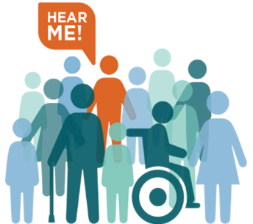

**What will you do?  
We will meet you and your support person* online through video chat or in-person. You will answer questions about your health.**

# How long will this take?

**About 3 hours.**

# *Who is a support person?

**A family member, friend, or caregiver that knows you well.**

**Want to sign up?**

**Call us Monday to Friday  
between 9:00am-5:00pm**

**833-678-7782**

**Scan here**

**OR go to**

[**go.osu.edu/rrtcstudy**](https://redcap.bmi.osumc.edu/redcap/surveys/?s=YP4KAFRCT4)

You will earn a $100 gift card.  
+   
Your support person will  
earn a $100 gift card.

**For more information, visit our website: www.rrtcnisonger.org**

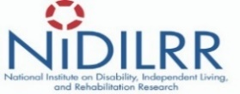

**The Ohio State University Nisonger Center has created a Rehabilitation Research and Training Center (RRTC) on Health and Function for People with IDD. This research is funded through the Administration for Community Living (ACL) (NIDILRR grant number 90RTHF0002).**