Mental Health
Therapy Toolkit

  - A personal guide for adults with intellectual disability
Use this toolkit to help your therapist know how best to support you.
- Add your information in the guide on the following pages.
Ask a support person for help, if needed, like a family member or friend.
- Share a copy with your therapist or mental health provider.
Ask your therapist to read your guide before meetings.
- Work with your therapist to review and update your guide often.
Ask your therapist to read the Psychotherapy Practice Guidelines https://nisonger.osu.edu/adult-psychotherapy-guidelines/
My Mental Health Therapy Guide
What You Need to Know About Me |  | Examples
 | What I like to go by: | your name; he/him, she/her, they/them
 | How best to communicate with me: | talking, text, video, communication device, extra time, visual aids, meeting reminders, calendar invites, email,  face-to-face, online
 | The accommodations or supports I need: | clear or plain language, large print, videos, visual aids, shorter or longer meeting times, social stories, examples, breaks
 | The support person(s) I want to help me: | family member, friend, care provider, direct support professional;  none, no support person
 | My disability or condition: | medical diagnosis,  mental health condition, strengths, challenges, what I like and do not like about my disabilities

 |  | My background, culture, and how I identify: |  | family, religion, beliefs, values, needs, identity, race, ethnicity, gender
 |  | My likes and dislikes: |  | hobbies, music, sports, books, shows, interests; things I like to do at my therapy sessions; things that make me sad, mad, upset, worried, or afraid
 |  | Important things about my past: |  | my experience with therapy, treatment, or other providers; good or bad events; adult and childhood memories; trauma, triggers, stress
 |  | My therapy goal(s) - what do I want to change or make better in my life? |  | learn new things to help me think or feel better;  talk about how my thoughts and feelings impact my life
 |  |  | Keep a copy of this guide in your  medical records or therapist’s notes. |  | 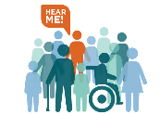
Client Quick Check:
- Did I agree to participate in therapy, even if I have a legal guardian?
- Do I need help from a support person to communicate with my therapist?
- Did I agree to include a support person and choose who I want?
- Do I feel safe and comfortable with my therapist? Did we build trust?
- Did I share my cultural background and preferred identities?
- Did I share my history of trauma and triggers that impact me?
- Am I in charge of my therapy? Am I making key decisions about my treatment?
- Is my therapist using accommodations and supports that meet my needs?
- Is my therapist using clear communication and plain language during therapy?
- Is my therapist speaking directly to me? Are they respecting my rights?

For more support: ID Mental Health Therapy Guidelines –
Treating Adults with Intellectual Disability and Mental Health Conditions

https://www.rrtcnisonger.org/products/clear-language/

The contents of this paper were developed as part of a Rehabilitation Research and Training Center (RRTC) on Health and Function awarded to The Ohio State University (OSU) Nisonger Center through a grant from the National Institute on Disability, Independent Living, and Rehabilitation Research (NIDILRR grant number 90RTHF0002-01-00). NIDILRR is a Center within the Administration for Community Living (ACL), Department of Health and Human Services (HHS). The contents of this paper do not necessarily represent the policy of NIDILRR, ACL, or HHS, and you should not assume endorsement by the Federal Government.

Recommended citation: The Ohio State University Nisonger RRTC on Health and Function. (2023). Mental Health Therapy Toolkit: A Personal Guide for Adults with Intellectual Disability.

  - 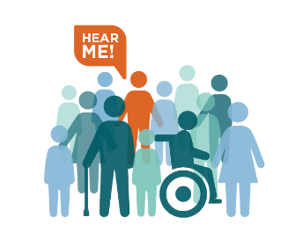
https://go.osu.edu/RRTC

